Name: _________________________________ Per: ________

A hypothesis can either be true or false. The same is true of a conclusion. For a conditional statement to be true, the hypothesis and conclusion do not necessarily have to be true. Determine whether each conditional statement is true or false. If it is false, write a conclusion that proves the statement false.

- If yesterday was Thursday, then today is Friday.

- If a month has 30 days, then it is September.

- If an even number is not divisible by 2, then 9 is a perfect cube.

- If Omar is a high school student, then he attends PV High.

- If a student is taking a foreign language, then they speak Japanese.

- If points A, B, and C are collinear, then they lie on the same line.

- If an angle is acute, then it has a measure of 30°.

Fill in the missing blanks to continue the pattern:
- 2, 4, ______ , 8, _______
- 0, 1, 1, 2, 3, 5, ______ , ________
- ↑, ↓, ←, →, ↑, _____ , ←, ________
- |, +, ̶, |, +, ̶, _______
- A, B, C, C, A, B, C, C, A, _______ , ________
- :o, , , :o, , _______ , ________

Name: ___________________________ Per: _______
Logic Problem: Dinner with the Montagues
Use the table to help you solve the logic problem. Each square represents a possible answer. Follow the rows and columns to find the correct combination. Draw a dot in a square for the answer where the vertical and horizontal squares meet. Draw an “x” in a square that isn’t the answer.
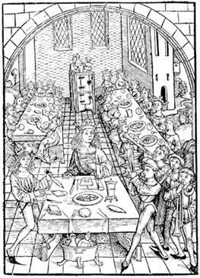
 | Stewed Veal | Roasted Pheasant | Salt-cured Pork Loin | Fried Trout | Muscat Pears | Chutney | Apple Chicken Sausage | Black & Sour Cherries
Romeo
Benvolio
Mercutio
Balthasar
Muscat Pears
Chutney
Apple Chicken Sausage
Black & Sour Cherries

The Montague family sat down for dinner at the castle. They each got a meal: stewed veal, roasted pheasant, salt-cured pork loin, and fried trout. Each family member had a different side with their meal: muscat pears, chutney, apple chicken sausage, and black & sour cherries. Use the clues below to find out what each Montague ate for dinner.

- Mercutio enjoyed chutney as his side dish
- Romeo did not have fried trout or salt-cured pork loin as his meal, but he did have apple chicken sausage
- Benvolio ate fried trout, but did not have black & sour cherries as his side
- The person who had salt-cured pork loin had black & sour cherries as their side dish
- The roasted pheasant dinner did not have apple
chicken sausage as the side

