**Geometry Points: _________ Name ________________________**

**Ch 13 Group Review Period _______**

1. Name the sets to which each number belong.

1. 
2. -2
3. 0.35
4. 0
5. Π

2. A = {1, 3, 5, 7, 9, 11} B = {2, 4, 6, 8, 10}

C = {0, 1, 3, 10}. Find…

1. A ∩ B =
2. A ∪ C =
3. (A ∩ C) ∪ B =

3. Write an equation of a line with the following conditions:

a. Through (2, 3) and (4, 1)

b. Through (1, -2) and perpendicular to 2x – 3y = 6

#3 continued

d. Through (7, 9) and parallel to 4x + 8y = 12

e. Perpendicular bisector of (2, 1) and (4, 5)

4. Graph the following:

a. 3x – 2y = -12 b. y 2x – 3

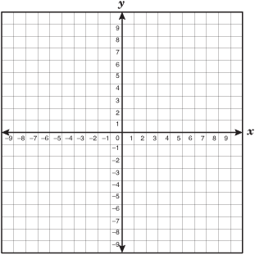

c.



5. Solve the systems by…

a. substitution $\left\{\begin{aligned}5x+y=14 \\ 2x+y=5\end{aligned}\right.$

b. substitution

6. Factor completely:

a. 25x2 – 25x – 36

b. b3 + b2 + b + 1

c. 16x4 – y4

d. 2x2 – 7x + 3

e. 3x3 +6x2 – 3x – 6

7. Solve for the given variable by…

a. factoring and using zero product property:

x2 – 12x + 36 = 0

b. quadratic formula: 6x2 + 7x = 3

c. completing the square: x2 – 7x + 5 = 0

**hint: keep everything in fractions!**

8. Simplify completely:

a. 

b. 

c. 

d. 

e. 

9. Solve. Graph only part (a) on a number line.

a.  b. 