**Geometry: Ch 13 Test Review (Day 2) Name: ____________ _____**

**1.** Write the equation of the line with the following conditions. Write all answers in slope-intercept form.

1. Through (0, 0) and (-3, 3)
2. Through (0, 10) and parallel to – y = 3 – 2x

**2.** Solve using the indicated method.

1. Substitution $\left\{\begin{aligned}y=x-6 \\ x+y=-2\end{aligned}\right.$
2. Elimination $\left\{\begin{aligned}x+4y=18 \\ 4x+3y=7\end{aligned}\right.$

**3.** Graph on the grid provided.

1. 3y = –2x – 1

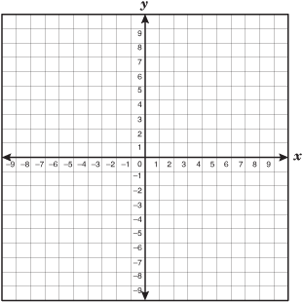

1. x + 3y > -10



**4.** Solve | *x* + 3 | ≤ 12

**5.** Factor completely.

1. x2 – 14x + 24
2. – ky – 4k + 7y + 28
3. 288y2 – 8
4. 9x2 – 24x + 16

**6.** Solve for the variable using the indicated method.

1. Factoring and zero product property

7x2 – 8x + 1 = 0

1. Take the square root of both sides

3x2 = 12

1. Quadratic Formula (Yes, factoring works, but use the Quadratic Formula to show your work)  
   x2 – 6x = 16

**7.** Circle the set(s) to which each number belongs.  
**N** = Natural **I** = Integer **Q’** = Irrational

**N0** = Whole **Q** = Rational **R** = Real

1.  **N N0 I Q Q’ R**
2.  **N N0 I Q Q’ R**
3. -27 **N N0 I Q Q’ R**
4. 0 **N N0 I Q Q’ R**

**8.** For sets A = {0, 5, 10, 15, 20} B = {0, 2, 4, 6, 8, 10, 12} C = {0, 2, 5, 8, 11}, find:

* 1. A ∩ C
  2. B ∪ C

**9.** Simplify completely. Assume all variables are positive.

a. 

1. 
2. 
3. 
4. 