Name: ___________________________________ Per: __________
Third Angles Theorem Practice
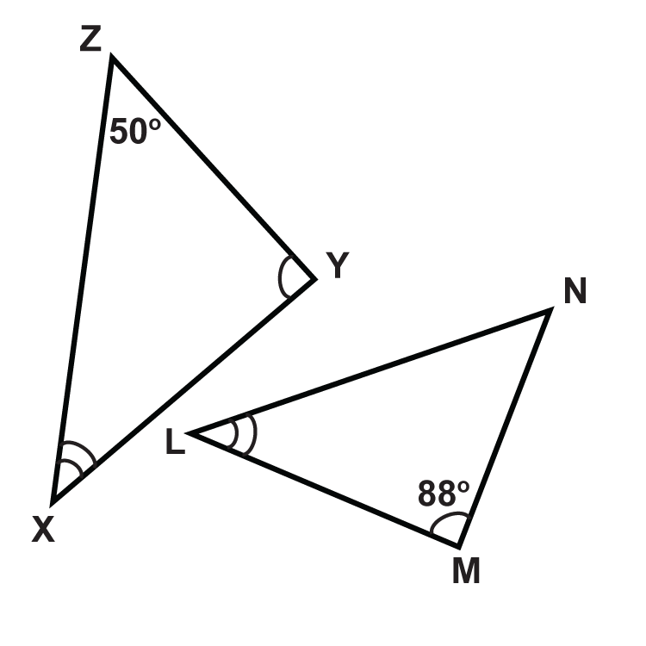
Determine the measures of the unknown angles. Show ALL your work!!!

- ∠Y
- ∠X
- ∠N
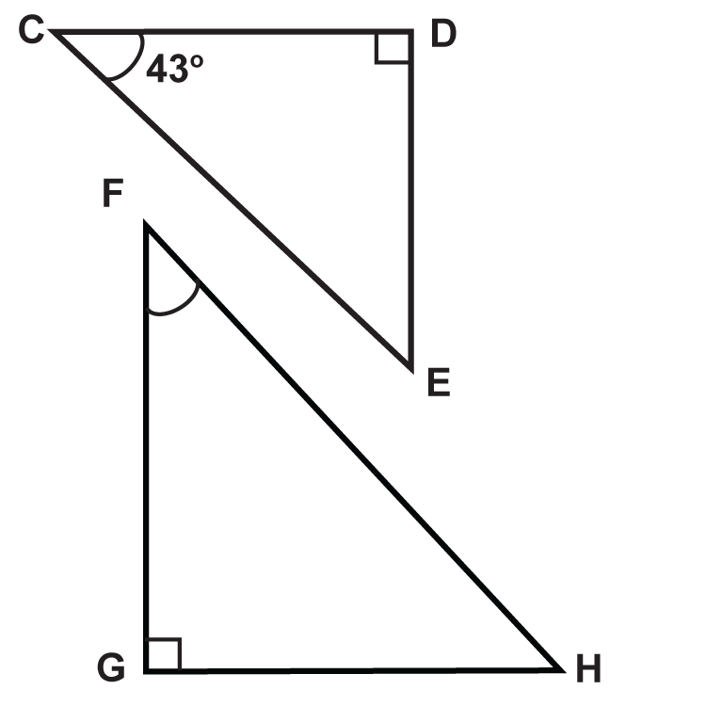
- ∠L

- ∠E
- ∠F
- ∠H
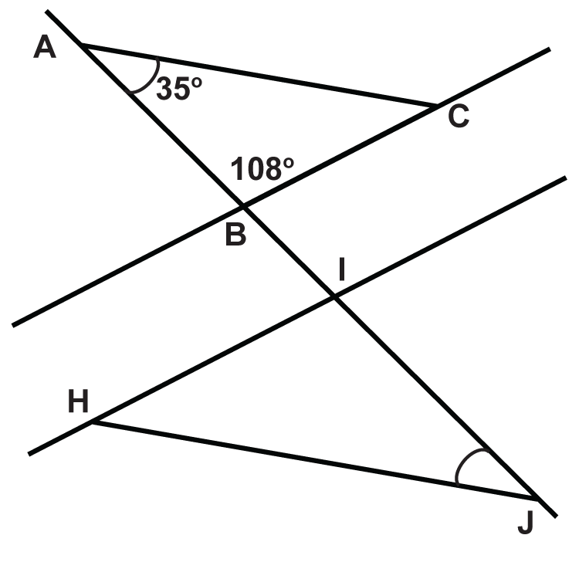
( Hint: You may assume that BC // HI )
- ∠ACB
- ∠HIJ
- ∠HJI
- ∠IHJ

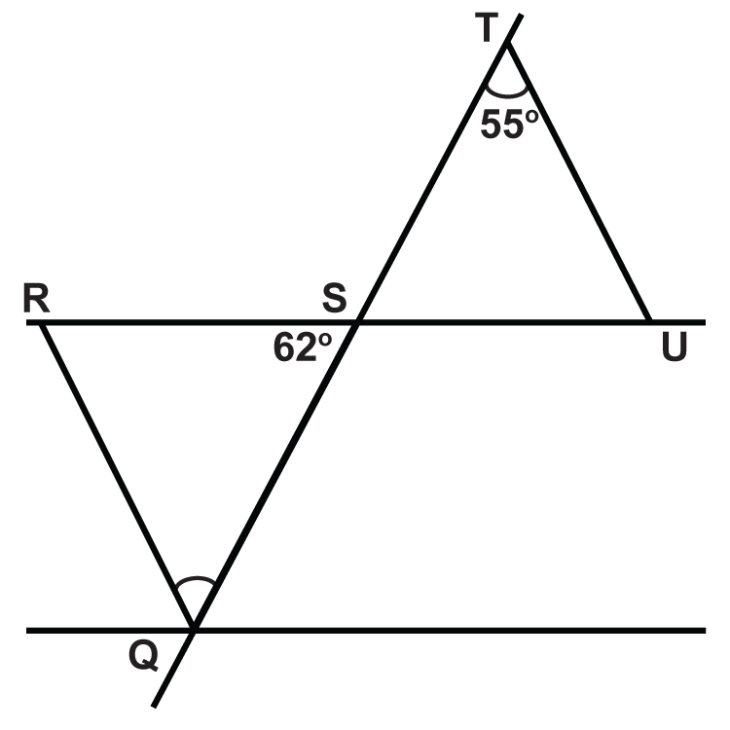
- ∠RQS
- ∠SRQ
- ∠TSU
- ∠TUS

