Project: Home Office Construction
Company Name: _____________________________________________________________________
Engineers/Architects: _________________________________________________________________
You want to finish your basement and use it as a home office. You plan to hire a contractor to do the work. The amount charged by the contractor is based on the area of the room to be finished. The amount, however, does not include the cost of flooring.
In this task, you will create a blueprint of the sketch of your basement below to be used to determine the area of the basement that will be finished by the contractor. You will also decide on the type of flooring that will go in the basement and price it so that you stay within your budget.
This project will be completed over the next few chapters. Each phase will help with the next phase. Please do not rush through your calculations. Be accurate, precise, and take pride in your work.
Phase 1 of 3: Creating a scale drawing (blueprint)
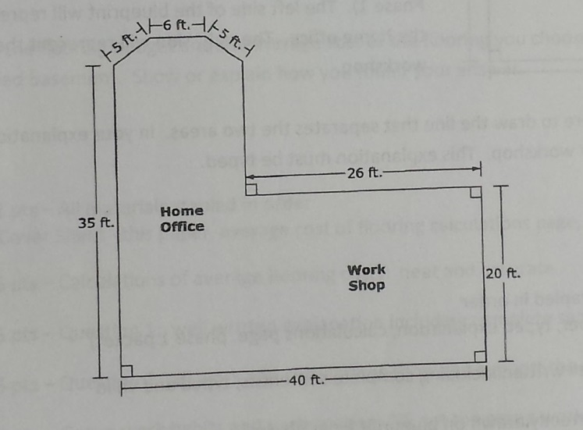
Use a piece of centimeter graph paper to make a scale drawing of the sketch below. Use the scale given to your group in class. Show all calculations in a designated calculation space on a separate piece of paper. Remember this is a document you will be presenting to a construction company to use during the home office construction, so be sure to make it presentable, accurate, and easy to follow.

Grading Rubric:
_____/3 pts – All materials stapled in order:
1. Cover Sheet (this page)
2. Calculations page
3. Scale drawing on graph paper
_____/15 pts – Calculations: accurate, neat, and easy to follow
_____/6 pts – Scale Drawing: accurate, neat, presentable
_____/6 pts – Group work habits and participation
(may vary by group member if need be)
_____/30 pts – Total score

