Name: ________________________________________________ Date ____________ Period _________

**Review – Sections 2.5-2.7**

1. 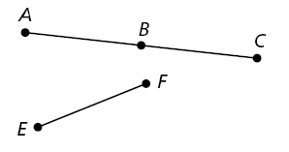Fill in the reasons for each step.

Given: $\overline{BC}≅\overline{EF}$



Prove: B is the midpoint of 

|  |  |
| --- | --- |
| **Statements** | **Reasons** |
| 1. $\overline{BC}≅\overline{EF}$ | 1. |
| 2. | 2. |
| 3. $\overline{AB}≅\overline{BC}$ | 3. |
| 4. B is the midpoint of | 4. |

1. Write a flowchart proof for the two-column proof you created in #1:
2. Use the choices below to identify the property for each statement.

A. Addition property of equality G. Transitive property of equality

B. Subtraction property of equality H. Substitution property of equality

C. Multiplication property of equality K. Distributive property

D. Division property of equality L. Reflexive property of congruence

E. Reflexive property of equality M. Symmetric property of congruence

F. Symmetric property of equality N. Transitive property of congruence

_______ a. ∠XYZ $≅$ ∠PQR, so ∠PQR $≅$ ∠XYZ

_______ b. CD = CD

_______ c. If *a* = 2 and *5a = 10*, then *5(2)=10*.

1. Write a biconditional statement for the definition: “A quadrilateral is a polygon that has 4 sides.”

__________________________________________________________________________________

__________________________________________________________________________________

1. 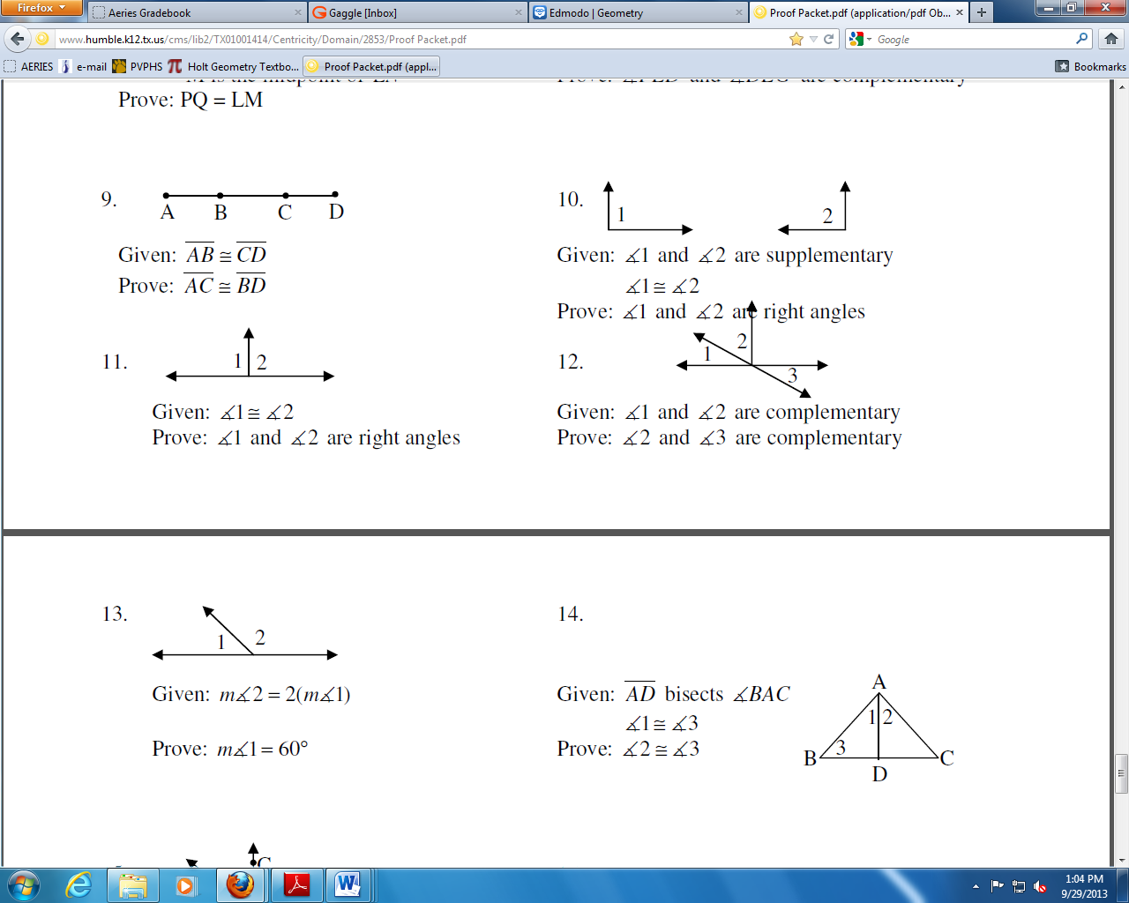Given: 

Prove: 

|  |  |
| --- | --- |
| **Statements** | **Reasons** |
| 1. | 1. Given |
| 2. AC = BD | 2. |
| 3. AC = AB + BC | 3. |
| 4. | 4. Segment Add. Post |
| 5. AB + BC = CD + BC | 5. |
| 6. | 6. SPE (Subtract. PE) |
| 7. | 7. |

1. Solve the equation below for x. Write a justification for each step

$$7x+3=5x+7$$

**Steps Justifications**